**Question 1:**

**What are Conditional statements? Explain conditional statements with syntax and examples?**

Conditional statements: Conditional Statements are decision making statements.

Conditional statements are used to control the flow of program.

Conditional statement is a set commands that executes when the specified condition is true.

JavaScript supports two types of conditional statements.

1. If. Else
2. Switch
3. **Simple .. If:**

It is simple if statement. If the condition is true, set of statements will execute.

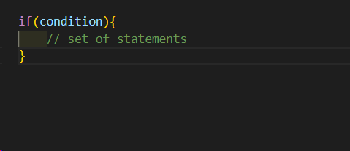

**Example:**

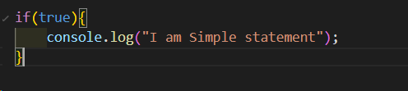

1. **If…Else:**

In if block, if the condition is true, the true block statements will execute.

If the condition is false, false block statements will execute.

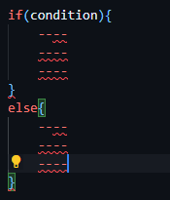

Example:

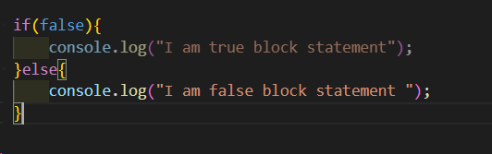

1. **Nested If:**

If we write if with in the if is said to be as Nested IF.

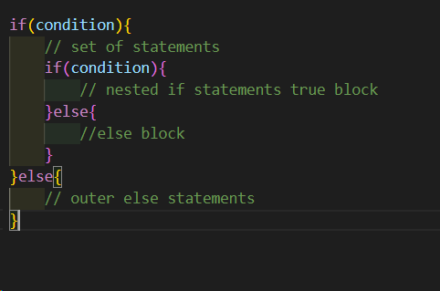

**Example:**

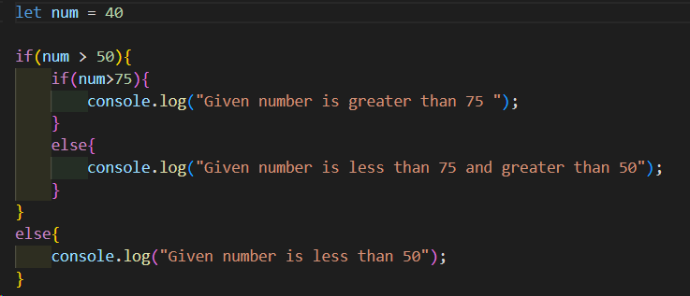

1. **If. Else ladder:**

If we check multiple conditions in a sequence, it is said to be as if else ladder.

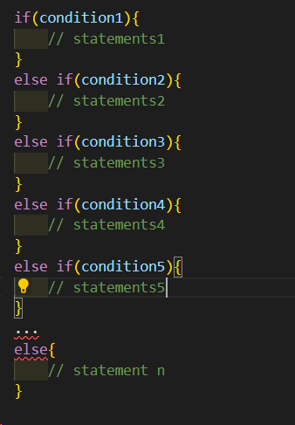

**Example:**

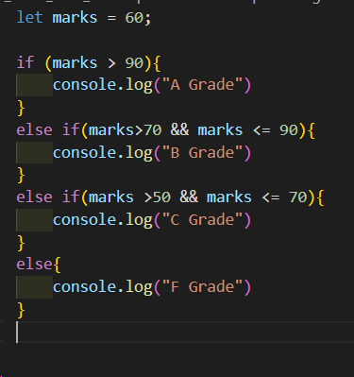

**Switch:**

In switch statement, if the expression is matched to any case label, then the set of statements will execute until break.

If the expression is not matched to any case label, then default statement will execute.

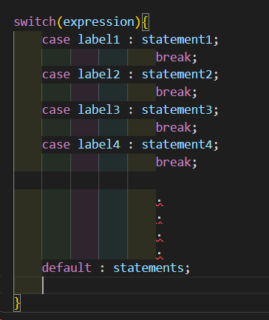

**Example:**

